Registered Mail Number: RE xxx xxx xxx US

THIS IS A PRIVATE COMMUNICATION BETWEEN THE PARTIES
NOTICE TO AGENT IS NOTICE TO PRINCIPAL -- NOTICE TO PRINCIPAL IS NOTICE TO AGENT

NOTICE OF TENDER FOR SETOFF
Date Goes Here, 2024

Principal:
FIRST MIDDLE LAST
1234 YOUR ADDRESS ST.
CITY / TOWN, ST 12345

Respondent:
C.E.O. / C.F.O. for
COMPANY NAME HERE
4321 THEIR ADDRESS ST.
CITY / TOWN, ST 12345

Re: NOTICE OF PAYMENT ON ACCOUNT NO. xxxxxxxxx; FIRST MIDDLE LAST

To whom it may concern:

Whereas, on Date Mailed to I.R.S., instruments of tender for setoff, hereinafter “Tender”, for the setoff of COMPANY NAME HERE account number ACCOUNT NUMBER, hereinafter “Account”, were presented for setoff to:

INTERNAL REVENUE SERVICE  AUSTIN SUBMISSION PROCESSING CENTER  P.O. BOX # 149213  AUSTIN, TX 78714 **SEE BELOW** | and | C.E.O. / C.F.O. for  COMPANY NAME HERE  4321 THEIR ADDRESS ST.  CITY / TOWN, ST 12345

Whereas, on Date of A4V Acceptance / Endorsement, the Tender is deemed accepted for the setoff of the ACCOUNT pursuant to and evidenced by the records enclosed herewith.

THEREFORE, First-Middle: Last, Undersigned, on behalf of FIRST MIDDLE LAST, hereinafter “Principal”, requests that the balance of the Account be adjusted to Zero dollars ($0.00) to reflect the ledgering of said Tender.

Enclosed herewith is a Request Regarding a Statement of Account pursuant to Uniform Commercial Code § 9-210 as a record authenticated by the debtor requesting that the Respondent approve or correct the statement. Respondent has fourteen (14) days to comply with this request and to provide an authenticated record.

Any and all responses shall be directed to the Principal by U.S.P.S. Certified or Registered Mail at the address listed above.

Service in any other manner will be deemed defective on its face.

Executed in Example County, Your State, this ______ day of Month, 2024. Witness my hand and seal.

By: _____________________________________
First Middle Last
Authorized Representative, Attorney in Fact
d/b/a FIRST MIDDLE LAST©, ens legis

NOTICE: THIS DOCUMENT IS NOT INTENDED TO THREATEN, TO HARASS, TO HINDER, OR TO OBSTRUCT ANY LAWFUL OPERATIONS. IT IS FOR THE PURPOSES OF OBTAINING LAWFUL REMEDY AS PROVIDED FOR BY LAW.

**I.R.S. ADDRESSES FOR YOUR STATE:**
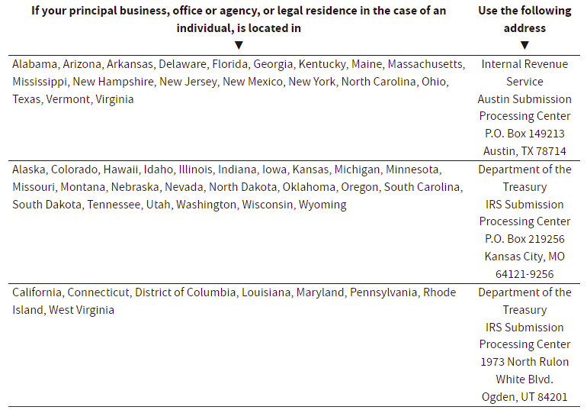
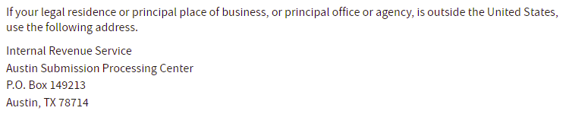
DELETE THIS AND ALL HIGHLIGHTED TEXT AFTERWARD

